

FACULTY OF INFORMATION AND COMMUNICATION TECHNOLOGY

PROG101 PRINCIPLES OF PROGRAMMING AND LOGIC DESIGN

Title : Waste Management System
Issue Date : Week 2
Due Date : Week 4
Lecturer/Examiner : Mr. AMADU KAMARA
Name of Student : VICCESS SARAH NYAMA
Student ID No. : 905005974
Class : B.S.E.M 01
Semester/Year : 1/1
Academic Honesty Policy Statement
I/We, hereby attest those contents of this attachment are my own work. Referenced works, articles, art, programs, papers or parts thereof are acknowledged at the end of this paper. This includes data excerpted from CD-ROMs, the Internet, other private networks, and other people’s disk of the computer system.
Student’s Signature: Date: 8/10/2026
LECTURER’S COMMMENTS/GRADE:

for office use only upon receive
Remark

DATE :
TIME :
RECEIVER’S NAME:
ABSTRACT
This project is about designing a Waste Management Billing System using Flowgorithm. The problem is that waste billing in many places in Sierra Leone, especially Freetown, is done manually which causes errors and wastes time. Different waste types have different disposal costs, but manual system does not handle it well. The aim of this project is to create an automated system that calculates waste fees based on type and weight. I used Flowgorithm to design flowchart and algorithm. The system collects waste type and weight from user, then calculates fee. The rates are $5 per kg for general waste, $2 per kg for recyclable waste, and $15 per kg for hazardous waste. It also allows continuous billing until user decides to stop. I tested the system with 10kg for each waste type and the results were $50 for general, $20 for recyclable, and $150 for hazardous waste, which shows the system works correctly. This system is useful for waste companies and local councils. It promotes clean environment and supports SDG 11 and SDG 12. The system can be open source and can become a Digital Public Good for Sierra Leone.

INTRODUCTION
Waste management is a big problem in our society today especially in places like Freetown where waste is increasing every day. Many houses and businesses produce different kinds of waste, and it is important to have a proper way to calculate the bill for collecting this waste. Before, people were doing the billing manually which can cause many mistakes. Sometimes they calculate wrong price and it wastes time. So, we need a computer system that can do the calculation fast and correctly. In this project, I designed a Waste Management Billing System using Flowgorithm. The system will ask the user to enter the type of waste and the weight, then it will calculate the total fee. The prices I used are $5 for general waste, $2 for recyclable waste and $15 for hazardous waste per kg. This is because hazardous waste is more dangerous and needs special care. The system also allows the user to do many transactions without starting again, by asking if they want to continue.
The billing rates used in this system are:
- General Waste: $5 per kg
- Recyclable Waste: $2 per kg
- Hazardous Waste: $15 per kg
The system allows users to enter waste type and weight, automatically calculates the fee, displays the result, and gives the option to continue with another transaction. This automation improves accuracy, saves time, and enhances transparency in waste management operations.

PROBLEM STATEMENT
Manual calculation of waste fees is slow and can cause error. Different staff charge different rates for same waste type. There is no clear visual flow that shows how fee is calculated. There is no system to allow many transactions in one run. Therefore, there is need for automated, standardized billing system that can calculate fees based on defined rates for different waste types.
2.1 AIM AND OBJECTIVES
Am:
To design and implement an automated Waste Management Billing System using Flowgorithm.
Specific Objectives:
i. To design a flowchart that logically represents the waste billing process.
ii. To develop an algorithm that calculates fees based on waste type and weight.
iii. To implement the system in Flowgorithm using decision and looping structures.
iv. To test the system with different waste categories to ensure accuracy.

2.2 SIGNIFICANCE OF THE STUDY
This study is significant because:
- It will reduce calculation errors and improve accuracy in billing.
- It will save time for both staff and customers.
- It provides a clear visual flowchart that can be easily understood and maintained.
- It promotes proper waste categorization by attaching different costs to different waste types.
- It serves as a learning tool for understanding algorithms, flowcharts, and programming logic.

3.0 BACKGROUND
Freetown is growing fast and more waste is produced daily. In many communities, waste collection is not regular and billing is not organized. Most waste companies still use paper and calculator. This project was chosen because waste management affects health and environment in Sierra Leone.

4.0 PROPOSED SOLUTION
My proposed solution is a Waste Management Billing System. It is a simple logical system that calculates fee based on type of waste and weight. The system uses decision structure to check if waste is general, recyclable or hazardous, and repetition structure to continue billing until user stops.

5.0 COMPUTATIONAL THINKING
a) Decomposition: I broke the problem into small parts: input waste type, input weight, calculate fee, display fee, ask to continue.
b) Pattern Recognition: I noticed that fee = weight _ rate, and rate depends on waste type.
c) Abstraction: I removed unnecessary details and focused only on waste type, weight and fee.
d) Algorithm Design: I arranged the steps in order to solve the problem logically.
6.0 ALGORITHM DESIGN
Step 1: Start
Step 2: Set continue = "yes"
Step 3: While continue == "yes" do
Step 4: Output "Enter waste type (general, recyclable, hazardous)"
Step 5: Input wasteType
Step 6: Output "Enter weight in kg"
Step 7: Input weight
Step 8: If wasteType == "general" Then fee = weight _ 5
Step 9: Else If wasteType == "recyclable" Then fee = weight _ 2
Step 10: Else If wasteType == "hazardous" Then fee = weight _ 15
Step 11: Output fee
Step 12: Ask if user wants to continue
Step 13: End While
Step 14: Stop
PSEUDOCODE
Declare wasteType as String
Declare weight as Real
Declare fee as Real
Declare continue as String
Set continue = "yes"
While continue == "yes"
Output "Enter waste type"
Input wasteType
Output "Enter weight"
Input weight
If wasteType == "general" Then
fee = weight * 5
Else If wasteType == "recyclable" Then
fee = weight * 2
Else If wasteType == "hazardous" Then
fee = weight * 15
End If
Output "Total fee is: " + fee
Output "Do you want to continue? yes/no"
Input continue
End While
End

7.0 FLOWCHART
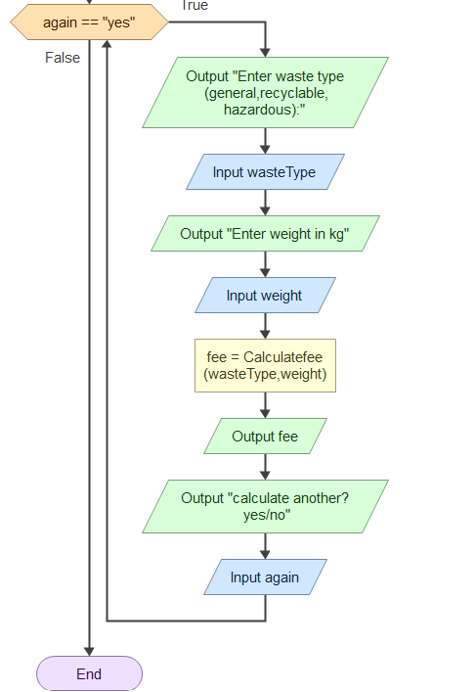
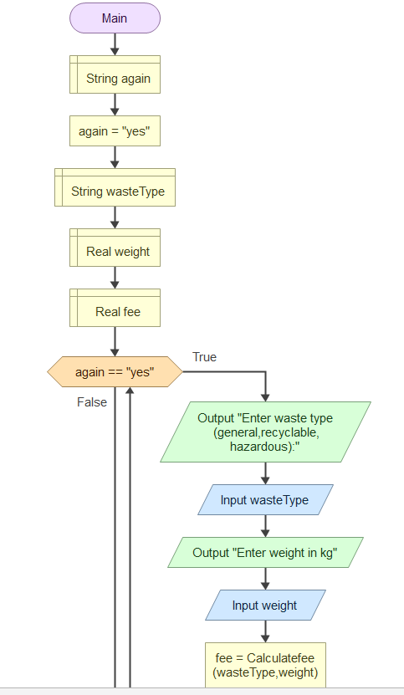

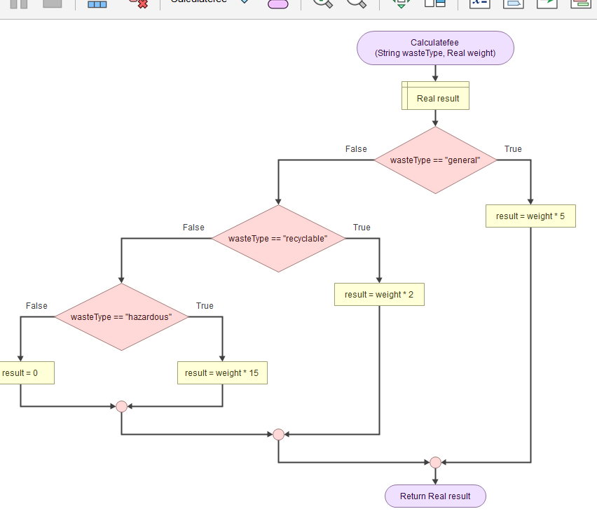

8.0 SDG ALIGNMENT
This project supports SDG 11: Sustainable Cities and Communities and SDG 12: Responsible Consumption and Production. By encouraging proper waste billing, people will be motivated to recycle more because recyclable waste is cheaper ($2). It also supports clean environment and good health (SDG 3).
9.0 OPENS OURCE JUSTIFICATION
The system should be Open Source because it is free for local councils and small waste companies in Sierra Leone who cannot afford expensive software. Students can improve it. Community contributions: Local developers can add features like mobile money payment, Krio language, and database.
10.0 DIGITAL PUBLIC GOOD (DPG) JUSTIFICATION
This system can become a Digital Public Good because it solves a public problem, it is open, and it can be used by anyone. It promotes accessibility, openness, and public benefit.
11.0 SIERRA LEONE COMMUNITY IMPACT
Problem being solved: Manual billing errors and poor waste management.
Expected Impact: Cleaner communities, fair billing, and people will recycle more.
Beneficiaries: Households, waste companies, Freetown City Council, and the environment.
Long-term Sustainability: The system can be updated and can be turned into a mobile app in future.
12.0 FUNCTIONAL MODULES
Module 1: Input Module – collects waste type and weight.
Module 2: Calculation Module – calculates fee using decision structure.
Module 3: Output Module – displays total fee.
Module 4: Control Module – asks if user wants to continue (loop).

13.0 EXPECTED OUTPUT AND TESTING
Test 1: general, 10kg -> Expected 50
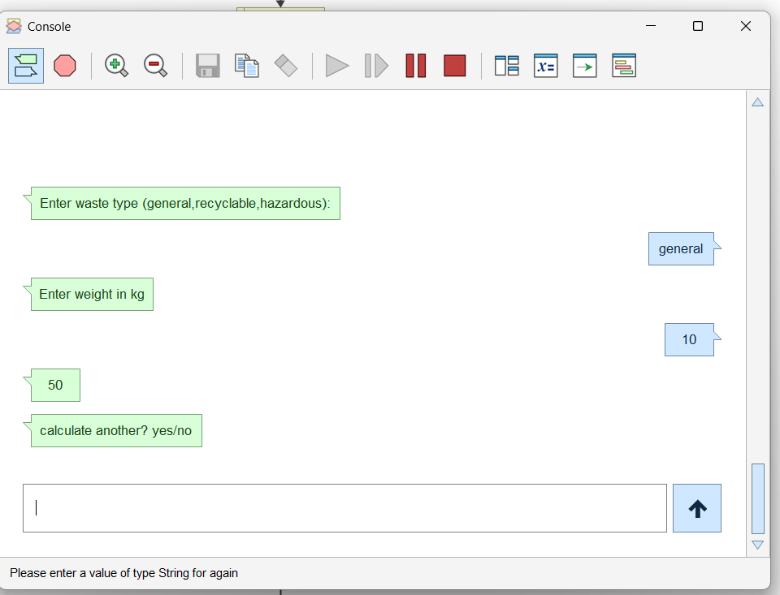

Test 2: recyclable, 10kg -> Expected 20
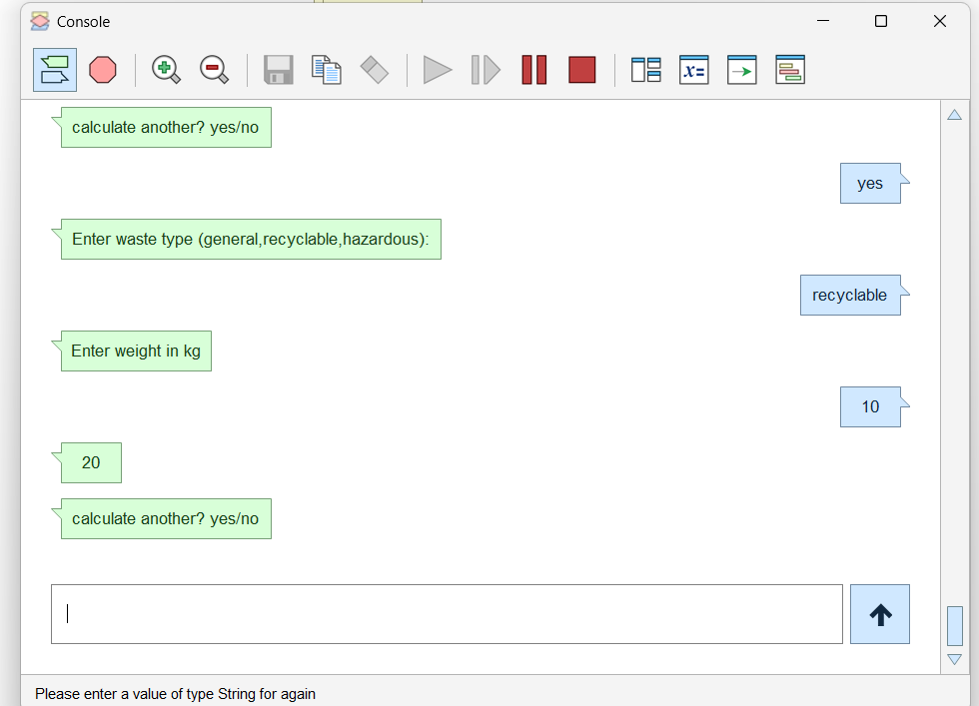

Test 3: hazardous, 10kg -> Expected 150
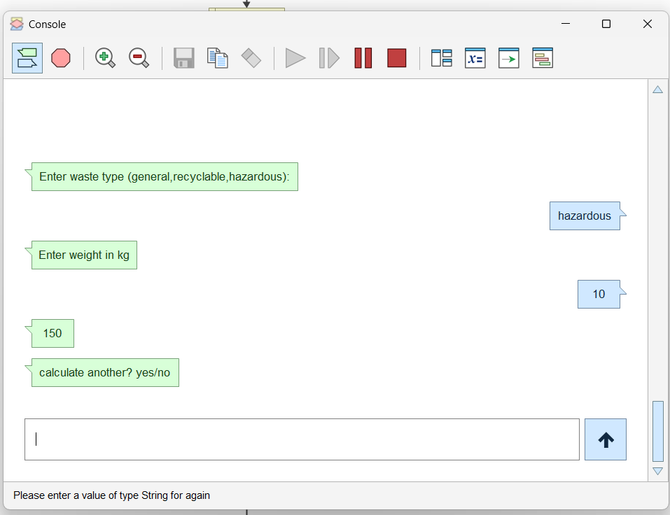

14.0 GITHUB AND EVIDENCE
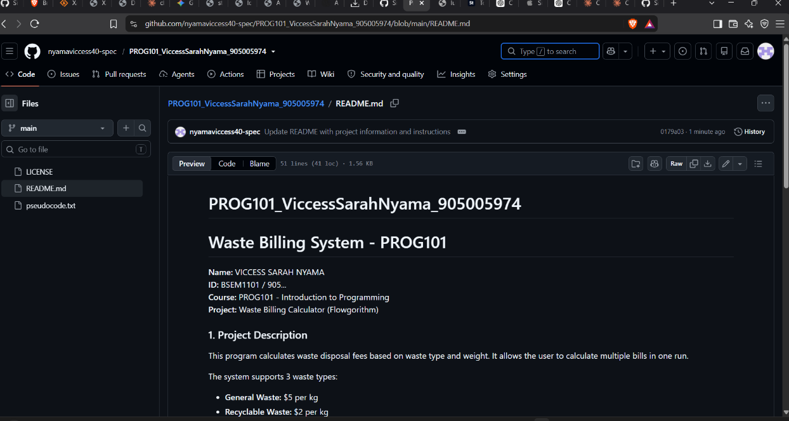

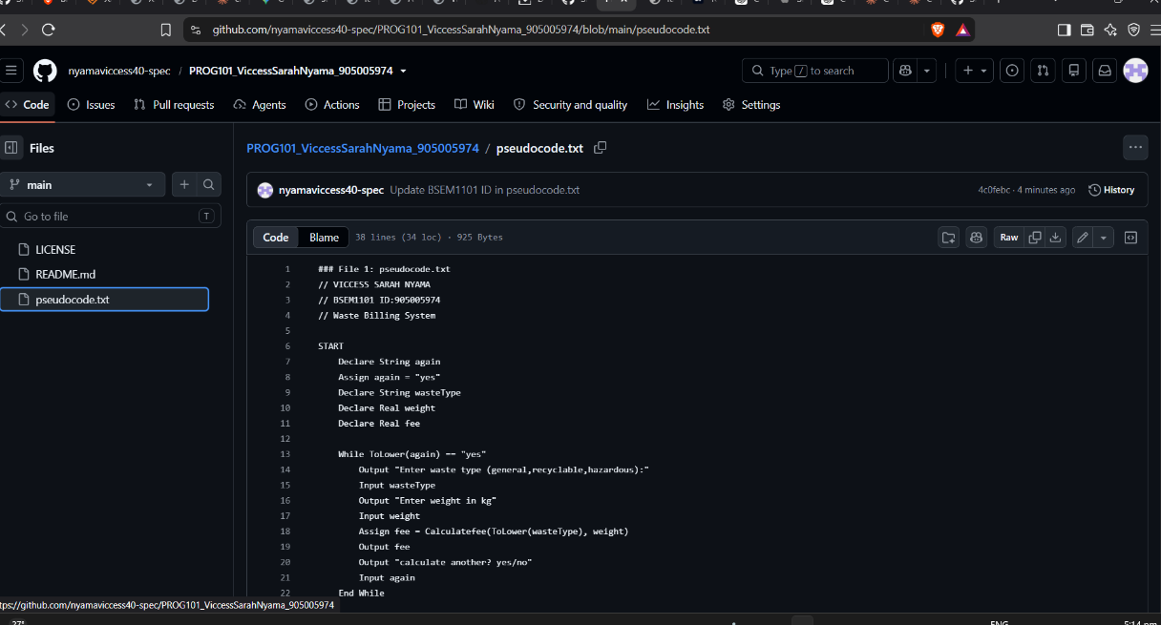

GitHub Link:
https://github.com/nyamaviccess40-spec/PROG101_ViccessSarahNyama_905005974.git

15.0 CONCLUSION
The Waste Management Billing System was successfully designed and implemented. The project achieved all its objectives. The system is efficient, accurate and user-friendly. It will help waste companies in Sierra Leone to do billing fast and correctly. In future, it can be improved with database and mobile app.

16.0 REFERENCES
Farrell, J., 2022. Programming Logic and Design. 10th edn. Boston: Cengage Learning.
Flowgorithm, 2024. Flowgorithm - Flowchart Programming Language. Version 4.0. Available at: http://www.flowgorithm.org/
Gaddis, T., 2023. Starting Out with Programming Logic and Design. 6th edn. London: Pearson Education.
GitHub, 2024. GitHub Documentation. Available at: https://docs.github.com/

